

YEAR: 7
2021
SUBJECT: Science

TEST: Ecosystems
TIME: 50 minutes
QUESTIONS: 12 Multiple Choice (12 marks)
Short Answer (34 marks)
TOTAL MARKS: 46 marks

DO NOT WRITE ON OR MARK THIS PAPER
SECTION ONE—MULTIPLE CHOICE (12 marks)

This section has 12 questions. Answer all questions on the separate Multiple-choice Answer Sheet provided.

- Plants are examples of:
  - decomposers
  - carnivores
  - producers
  - consumers

- Bacteria and fungi belong to an ecosystem groups called:
  - herbivores
  - decomposers
  - plants
  - composers

- Which of the following is the best definition for an omnivore?
  - an organism that feeds on dead things
  - an animal that eats plants only
  - an organism that eats both plants and animals
  - an organism that eats animals

- What do the arrows in a food web and food chain represent?
  - the organism that eats the other
  - the flow of energy
  - the organism that is eaten by the other
  - the herbivores in the system

- As you move up the Energy Pyramid:
  - the number of organisms stays the same, but the size decreases
  - the number of organisms increase
  - the number of organisms decreases
  - the number of organisms stays the same, but the size increases

- Select from the options below why the European wasp was introduced to Australia.
  - to help pollinate
  - to control the population of insects
  - they were accidentally introduced
  - for the cane toad to eat

Use the food web below to answer questions 7-9.

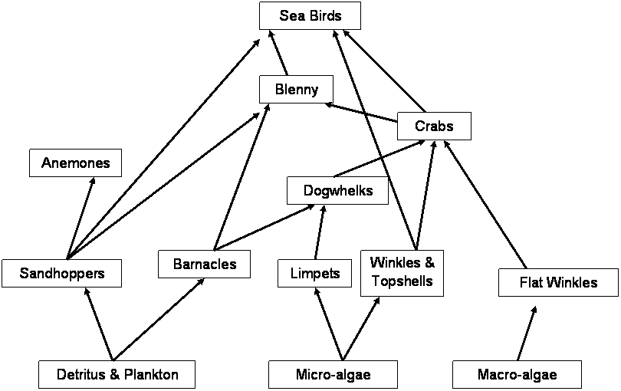

- How many primary consumers are in the food web?
  - 3
  - 5
  - 3
  - 4

- How many organisms are both secondary and tertiary consumers in this food web?
  - 3
  - 2
  - 5
  - 4

- If decomposers were removed from this food web:
  - nutrients would not be returned to the soil in order for producers to grow healthy
  - waste and dead organisms would pile up
  - there would be a break down in the flow of energy
  - all of the above

- Which of the following is not an introduced species?
  - cane toad
  - rabbit
  - feral cat
  - kangaroo

- Which of the following is one way that Aboriginal and Torres Strait Islanders people positively impact their local ecosystems?
  - Hunting down top predators in the food web.
  - Gathering plants to use for medicines.
  - Clearing land for housing.
  - Controlled fires to increase biodiversity.

- What is the main result of the production of palm oil for human use?
  - Salinity
  - Deforestation
  - Culling
  - Urbanisation

END OF MULTIPLE CHOICE SECTION
Please continue with short answer section in the answer book.



SEMESTER TWO 2021
Ecosystems Test:
ANSWER BOOKLET

NAME:
FORM: DATE:

I CAN STATEMENT | QUESTIONS
MUST  Makes predictions about the effects of environmental change on directly-connected organisms within a food web. | 1, 2, 3, 4, 6, 10, 11, 12, 13, 14, 15, 16, 17, 20, 22, 23 & 25
SHOULD  Makes predictions about and explains the effect of environmental change on populations within the food web. | 5, 7, 8, 18, 20, 22, 23 & 24
COULD  Makes predictions about and explains the effect of environmental change on the entire food web or community. | 9, 19, 20 & 21

Multiple Choice Short Answer Total

/34

/12

/46

SECTION ONE: Multiple choice answers
Cross (X) through the correct answer.

1 | a | b | c | d
2 | a | b | c | d
3 | a | b | c | d
4 | a | b | c | d
5 | a | b | c | d
6 | a | b | c | d
7 | a | b | c | d
8 | a | b | c | d
9 | a | b | c | d
10 | a | b | c | d
11 | a | b | c | d
12 | a | b | c | d

SECTION TWO: Short Answer (34 marks)

Answer the questions in the spaces provided.

- What is the difference between a food web and a food chain? (1 mark)

- Classify the following list as either a producer or consumer. (4 marks)
Organism | Producer or consumer?
Cat
Magpie
Rose
Eucalypt
Sparrow
Worm
Ant
Rotting tree log

- What is the primary source of energy for all life on earth? (1 mark)

- Put the following tropic levels in order in the correct boxes below: (1 marks)
Secondary Consumer, Primary Consumer, Quaternary Consumer, Tertiary consumer, Producer

- Draw a line clearly linking the term to the definition. (3 marks)
Term: |  | Definition
Producer |  | The process by which green plants and other organisms convert sunlight to energy.
Quaternary Consumer |  | Organism that gains energy by eating other organisms.
Photosynthesis |  | Organism found at the start of the food chain. Always plant or plant-like organism that convert sunlight to energy.
Consumer |  | First-order consumer. Organisms that eat the producer.
Introduced species |  | Fourth-order consumer.
Primary Consumer |  | Organisms that are not naturally part of the ecosystem. They were brought in by humans.

- Construct a food chain from the following information: (3 marks)
A shark swims through the ocean in search of seals. In turn, seals search for large fish. Large fish have a diet of smaller fish. Floating in the water are millions of plankton. These are microscopic producer organisms that provide food for smaller fish and other herbivorous animals in the ocean.
FOOD CHAIN

- Use the following information to construct a food web in the box below: (5 marks)
Algae (producer)  Snail (eats algae) | Small fish (eats algae and snails)  Water beetle (eats small fish) | Frog (eats beetles)  Snake (eats beetles and frogs)

- Examine the food web below: (6 marks)

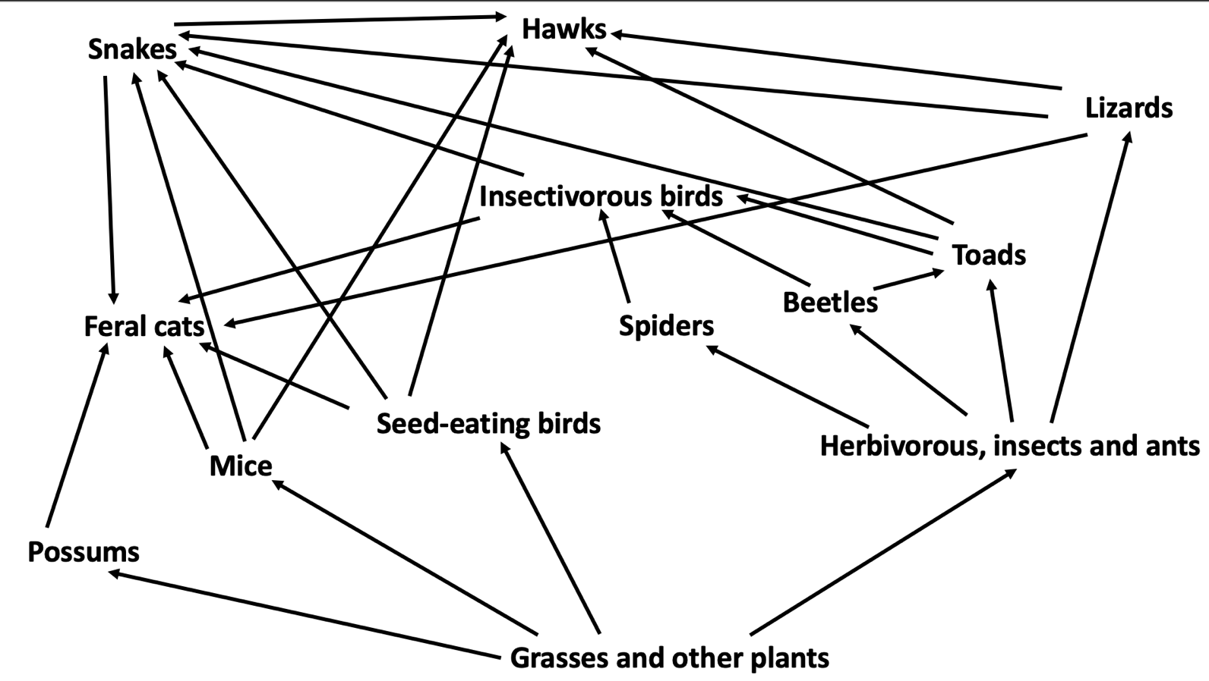

- Identify the producer: _____________________________________________________________
- Identify the top order consumers: ___________________________________________________
- Complete the food chain so that it ends with a hawk:
Grasses and other plants ---> _______________ ---> ________________ ---> ______________
- Using the food web above, identify a different food chain from the one in part C (you can use the same producer, include the consumers).

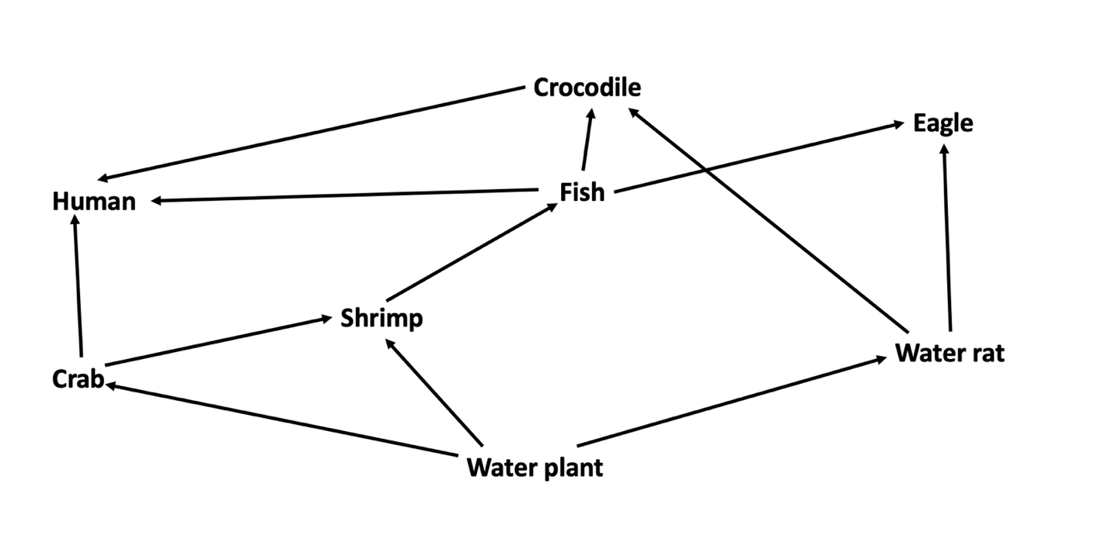
- Use the food web above to complete the following questions. (2 marks)

  - Propose what would happen to the eagle population if the water plant population was significantly reduced due to rise in water temperature.

  - Justify your proposal above.

- This food web represents a freshwater creek ecosystem.

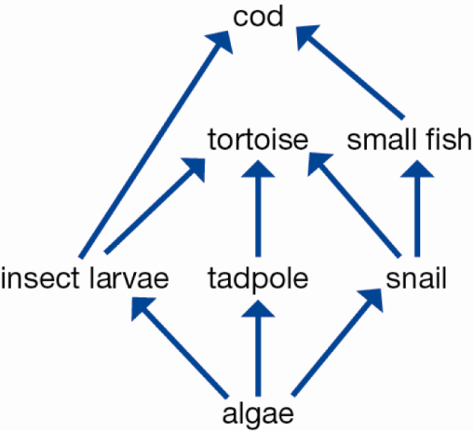

  - Draw the decomposer on the food web above. (1 mark)
  - Explain why this community could not survive without the algae. (1 mark)
______________________________________________________________________________________________________________________________________________________

- Aboriginal and Torres Strait People look after Country in accordance to their culture and customs. Describe one way the Aboriginal and Torres Strait Islander People manage invasive species.

(2 marks)

____________________________________________________________________________________________________________________________________________________________________________________________________________________________________________________________________________________________________________

- List four ways in which humans damage ecosystems. (4 marks)

  - ______________________________________________________________________________________________________________________________________________________
  - ______________________________________________________________________________________________________________________________________________________
  - ______________________________________________________________________________________________________________________________________________________
  - ______________________________________________________________________________________________________________________________________________________

END OF TEST
Please go back and check your work!

